1)

1. Write a set of iptables rules in the forward chain to allow RDP traffic from IP 196.1.113.4 only

iptables -I FORWARD -p tcp -m tcp --dport 3389 -s 196.1.113.4 -j ACCEPT

1. Write a set of ip tables rules in the forward chain to allow incoming HTTP port 80 and HTTPS port 443 traffic to the web server

iptables -I FORWARD -p tcp -m multiport --dports 80,443 -j ACCEPT

1. Write a set of ip tables rules to log packets directed to port 3389 (RDP)

iptables -A INPUT -p tcp --dport 3389 -j LOG --log-prefix "RDP traffic" --log-level 4

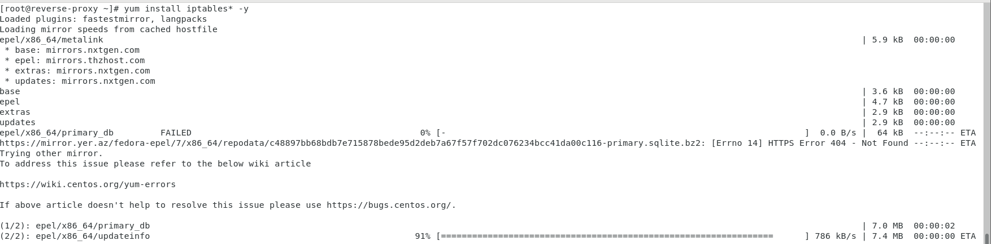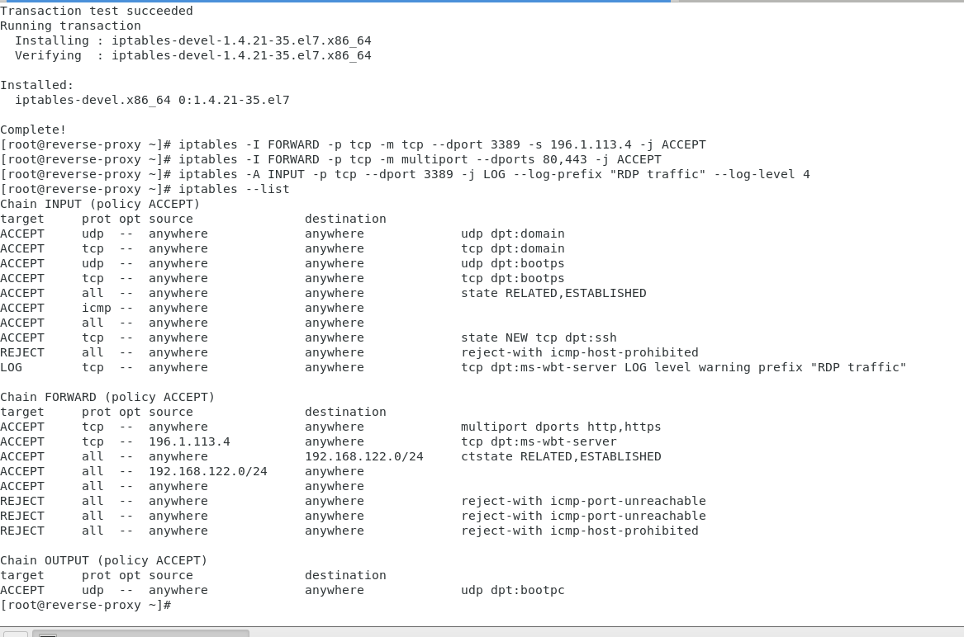

**Configuring the public IP 196.1.113.45**

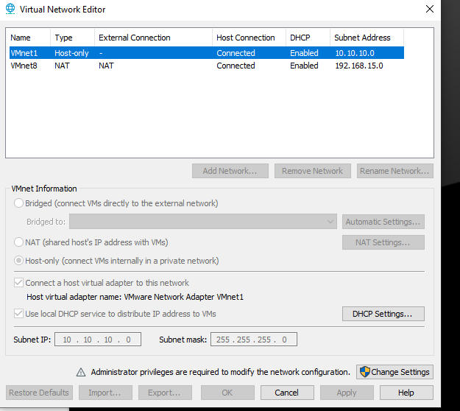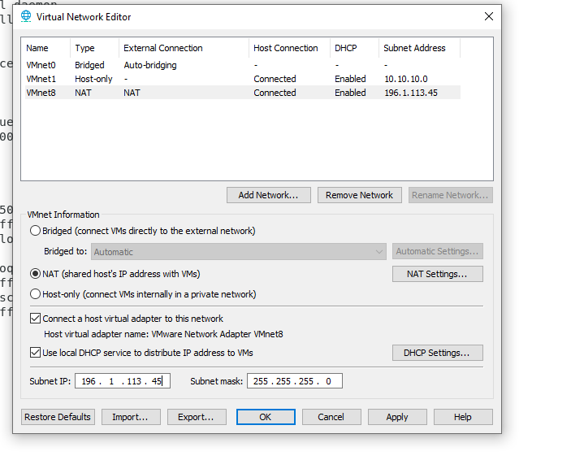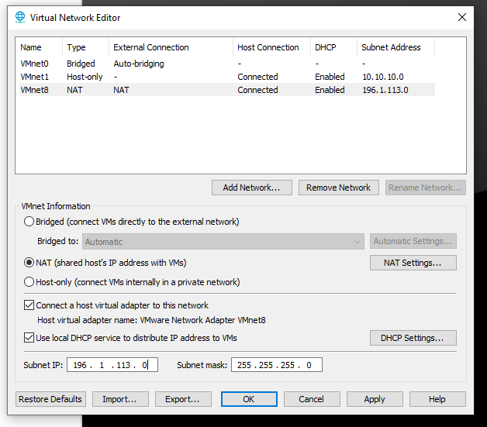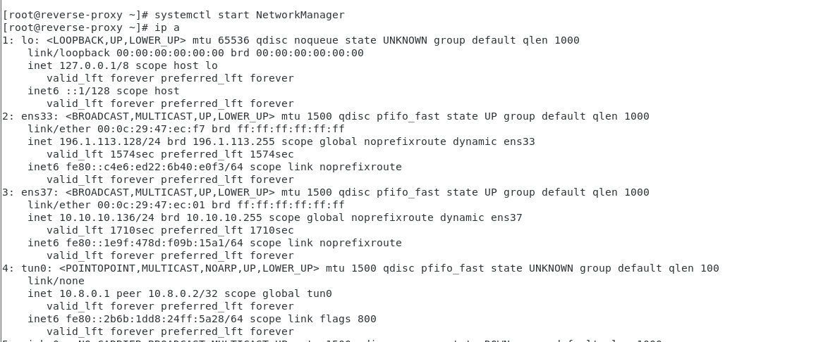

2) configuring Two Linux Machine

Open vpn 🡪 NAT and host only

Client 🡪 host only

